**Name, Last name: Emre Topcu**

**Student No: 20220808011**

**LAB03 Assignment**

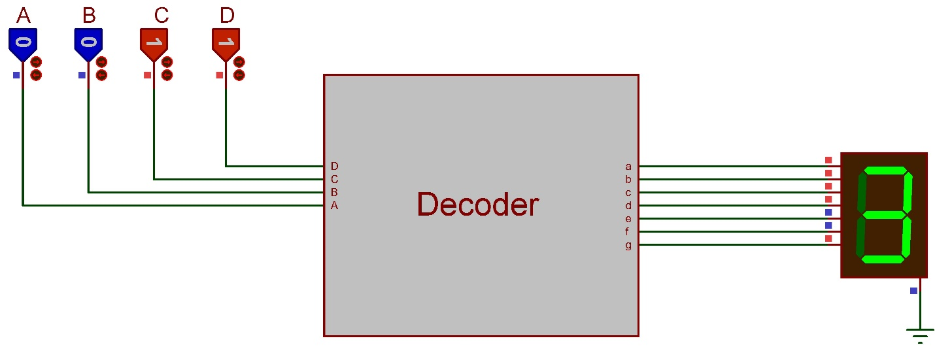

Your task is to design a decoder circuit that runs a 7-segment display. The circuit must show the numbers from 0 to 9 that is controlled with 4-bit input (ABCD). The steps you should do as follows.

1. Fill the truth table in page 2 based on the led statuses given in the picture above.

2. **Fill the Karnough Maps** on the page 3 to obtain the simplest Boolean function for each LED (from **a** to **g**) of the 7-segment display. We did first 3 LED (a,b,c) in the Lab class. Fill the karnough maps in page 3 and write the functions you obtained to the last raw of each K-Map table. For each rectangle use different colors on the rectangles to make the table easy to understand (Example tables is given in the first K-Map which is for Fa, Fb, Fc). (To add rectangle you can copy and paste existing ones)

**PS: Upload the completed version of this file as a single .pdf file.**

3. Finally, design the Boolean functions on Proteus Design Suite. (Use JUMPERS as we did in the lab!). Upload the project file. 7 Segment display must show all the digits (0-9) correctly corresponding to BCD input. A base design file is given in the assignment.

**PS: Don’t forget to fill your name and student number.**

**Truth Table**

|  |  |  |  |  |  |  |  |  |  |  |  |
| --- | --- | --- | --- | --- | --- | --- | --- | --- | --- | --- | --- |
| **Digit** | **Inputs** | | | | **Outputs (Seven Segment Led Pins)** | | | | | | |
| **A** | **B** | **C** | **D** | **a** | **b** | **c** | **d** | **e** | **f** | **g** |
| **0** | 0 | 0 | 0 | 0 | 1 | 1 | 1 | 1 | 1 | 1 | 0 |
| **1** | 0 | 0 | 0 | 1 | 0 | 1 | 1 | 0 | 0 | 0 | 0 |
| **2** | 0 | 0 | 1 | 0 | 1 | 1 | 0 | 1 | 1 | 0 | 1 |
| **3** | 0 | 0 | 1 | 1 | 1 | 1 | 1 | 1 | 0 | 0 | 1 |
| **4** | 0 | 1 | 0 | 0 | 0 | 1 | 1 | 0 | 0 | 1 | 1 |
| **5** | 0 | 1 | 0 | 1 | 1 | 0 | 1 | 1 | 0 | 1 | 1 |
| **6** | 0 | 1 | 1 | 0 | 1 | 0 | 1 | 1 | 1 | 1 | 1 |
| **7** | 0 | 1 | 1 | 1 | 1 | 1 | 1 | 0 | 0 | 0 | 0 |
| **8** | 1 | 0 | 0 | 0 | 1 | 1 | 1 | 1 | 1 | 1 | 1 |
| **9** | 1 | 0 | 0 | 1 | 1 | 1 | 1 | 1 | 0 | 1 | 1 |

|  |  |  |  |  |  |  |  |  |  |  |  |  |  |  |  |  |  |  |  |  |  |  |  |  |  |  |  |  |  |  |  |  |  |  |  |  |  |  |  |  |  |  |  |  |  |  |  |  |  |  |  |  |  |  |  |  |  |  |  |  |  |
| --- | --- | --- | --- | --- | --- | --- | --- | --- | --- | --- | --- | --- | --- | --- | --- | --- | --- | --- | --- | --- | --- | --- | --- | --- | --- | --- | --- | --- | --- | --- | --- | --- | --- | --- | --- | --- | --- | --- | --- | --- | --- | --- | --- | --- | --- | --- | --- | --- | --- | --- | --- | --- | --- | --- | --- | --- | --- | --- | --- | --- | --- |
| |  |  |  |  |  | | --- | --- | --- | --- | --- | | **CD**  **AB** | **00** | **01** | **11** | **10** | | **00** | **1** | **0** | **1** | **1** | | **01** | **0** | **1** | **1** | **1** | | **11** | **X** | **X** | **X** | **X** | | **10** | **1** | **1** | **X** | **X** | | **B’D’ + BD + C + A** | | | | | | |  |  |  |  |  | | --- | --- | --- | --- | --- | | **CD**  **AB** | **00** | **01** | **11** | **10** | | **00** | **1** | **1** | **1** | **1** | | **01** | **1** | **0** | **1** | **0** | | **11** | **X** | **X** | **X** | **X** | | **10** | **1** | **1** | **X** | **X** | | **C’D’ + CD + B’** | | | | | |
| |  |  |  |  |  | | --- | --- | --- | --- | --- | | **CD**  **AB** | **00** | **01** | **11** | **10** | | **00** | **1** | **1** | **1** | **0** | | **01** | **1** | **1** | **1** | **1** | | **11** | **X** | **X** | **X** | **X** | | **10** | **1** | **1** | **X** | **X** | | **C’ + D + B** | | | | | | |  |  |  |  |  | | --- | --- | --- | --- | --- | | **CD**  **AB** | **00** | **01** | **11** | **10** | | **00** | **1** | **0** | **1** | **1** | | **01** | **0** | **1** | **0** | **1** | | **11** | **X** | **X** | **X** | **X** | | **10** | **1** | **1**  “ | **X** | **X** | | **A + B’D’ + B’C + CD’ + BC’D** | | | | | |
| |  |  |  |  |  | | --- | --- | --- | --- | --- | | **CD**  **AB** | **00** | **01** | **11** | **10** | | **00** | **1** | **0** | **0** | **1** | | **01** | **0** | **0** | **0** | **1** | | **11** | **X** | **X** | **X** | **X** | | **10** | **1** | **0** | **X** | **X** | |  | | | | | | |  |  |  |  |  | | --- | --- | --- | --- | --- | | **CD**  **AB** | **00** | **01** | **11** | **10** | | **00** | **1** | **0** | **0** | **0** | | **01** | **1** | **1** | **0** | **1** | | **11** | **X**  c | **X** | **X** | **X** | | **10** | **1** | **1** | **X** | **X** | | **C’D’ + A + BC’ + BD’** | | | | | |
| |  |  |  |  |  | | --- | --- | --- | --- | --- | | **CD**  **AB** | **00** | **01** | **11** | **10** | | **00** | **0** | **0** | **1** | **1** | | **01** | **1** | **1** | **0** | **1** | | **11** | **X** | **X** | **X** | **X** | | **10** | **1** | **1** | **X** | **X** | | **A + BC’ + CD’ + CB’** | | | | | |  |